Observation: SAML Assertion Correctly Uses xml-exc-c14n#WithComments — Recommended Algorithm Confirmed
Result: No Vulnerability — Positive Observation | Status: Closed | Dependency: Microsoft Entra ID
Description
Testing included a review of the XML canonicalization algorithm used within SAML assertions issued by Microsoft Entra ID during the SSO authentication flow. Canonicalization in SAML refers to the process of converting an XML document to a standard form before computing its digital signature — the choice of algorithm directly determines resistance to XML Signature Wrapping (XSW) attacks.
The Burp Suite Inspector panel confirmed that the SAML assertion uses Exclusive XML Canonicalization (exc-c14n):
http://www.w3.org/2001/10/xml-exc-c14n#WithComments
This is the Exclusive XML Canonicalization with Comments variant. The table below compares all three canonicalization algorithms:
Algorithm | Type | Security Assessment
xml-c14n# (Inclusive C14N) | Weak / Avoid | Includes parent namespace declarations — susceptible to XML Signature Wrapping (XSW) attacks
xml-exc-c14n# (Exclusive C14N) | Acceptable | Excludes unnecessary namespace context and XML comments — XSW-resistant but does not preserve comment nodes in the canonical form
xml-exc-c14n#WithComments (Recommended — Observed) | Correct — Observed | The recommended algorithm for SAML 2.0 — exclusive canonicalization that preserves XML comment nodes in the canonical form, ensuring full fidelity of the signed XML document. XSW-resistant and SAML spec compliant.

The full set of cryptographic elements observed in the SAML assertion are all correctly configured:
SAML Element | Value Observed
CanonicalizationMethod | http://www.w3.org/2001/10/xml-exc-c14n#WithComments
SignatureMethod | http://www.w3.org/2001/04/xmldsig-more#rsa-sha256
Transform Algorithm | http://www.w3.org/2000/09/xmldsig#enveloped-signature
Transform Algorithm (C14N) | http://www.w3.org/2001/10/xml-exc-c14n#WithComments
DigestMethod | http://www.w3.org/2001/04/xmlenc#sha256

Why This Matters: Inclusive C14N (the weaker alternative) includes parent namespace declarations when computing the signature. An attacker can exploit this by wrapping the signed element inside a new parent with a different namespace, causing the signature to remain valid while the assertion content has been tampered with — a classic XML Signature Wrapping (XSW) attack. Exclusive C14N eliminates this attack vector by only including namespaces that are directly referenced. The WithComments variant is the recommended form for SAML 2.0 — it retains XML comment nodes in the canonical form ensuring the signed document is fully representative of the original XML, preventing any ambiguity between the signed and unsigned representations.
Replay Testing Result: SAML replay was also tested (Finding 2) and confirmed blocked by Okta's one-time-use enforcement. Combined with the correct exc-c14n#WithComments canonicalization, the SAML signature implementation is robust against both wrapping and replay attacks.
Tested Systems & Locations
https://login.microsoftonline.us/f9724c3f-5875-41b3-b99a-b6eee358ee32/saml2 (Microsoft Entra ID GovCloud SAML endpoint)
https://snyk-fedramp.okta.com/sso/saml2/ (Okta SP SAML endpoint)
Verification Steps
1. Configure Burp Suite to intercept all SSO traffic and complete a full login flow to app.snykgov.io.
2. In Burp HTTP History, locate the POST to login.microsoftonline.us returning HTTP 200 (row 37 in the screenshot).
3. Click the Response tab → Inspector panel → JSON Web Token tab.
4. In the Inspector panel on the right, locate the ds:CanonicalizationMethod element.
5. Confirm the Algorithm attribute reads: http://www.w3.org/2001/10/xml-exc-c14n#WithComments (highlighted in yellow in Figure 1).
6. Confirm SignatureMethod uses rsa-sha256 and DigestMethod uses xmlenc#sha256 — both strong algorithms.
Figure 1 — Burp Suite Inspector showing xml-exc-c14n# canonicalization algorithm (highlighted in yellow) within the SAML assertion
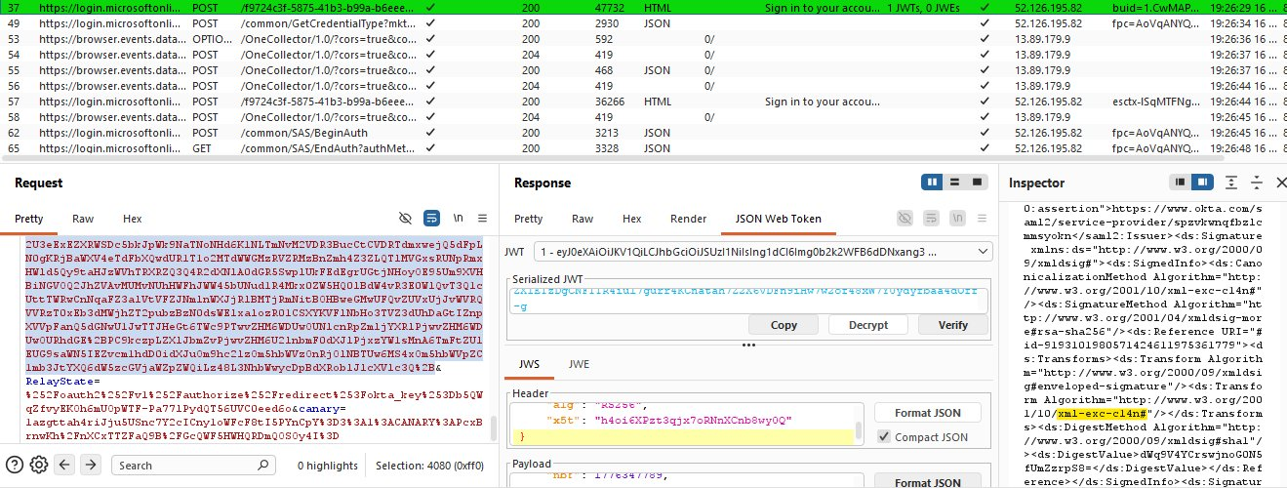
Recommendation
• No remediation required. The correct exc-c14n algorithm is in use and no change is needed.
• Include this as a positive control observation in the FedRAMP SSP — document that SAML canonicalization has been verified as exc-c14n and is resistant to XSW attacks.
• If the SAML configuration is ever changed or the IdP is migrated, re-verify the CanonicalizationMethod to ensure xml-exc-c14n#WithComments is retained as the canonicalization algorithm.
Closing Justification
Closed — positive observation. The SAML implementation correctly uses Exclusive XML Canonicalization with Comments (xml-exc-c14n#WithComments) — the recommended algorithm for SAML 2.0 — with RSA-SHA256 signatures and SHA-256 digest. This meets SAML 2.0 specification requirements and NIST SP 800-63C guidance. No vulnerability exists. This observation confirms that XML Signature Wrapping attack vectors were tested and found to be fully mitigated. The xml-exc-c14n#WithComments algorithm should be retained in all future SAML configuration changes.

